In class Lab – Data Structures and Algorithms

Index no- 210670N

Section 1

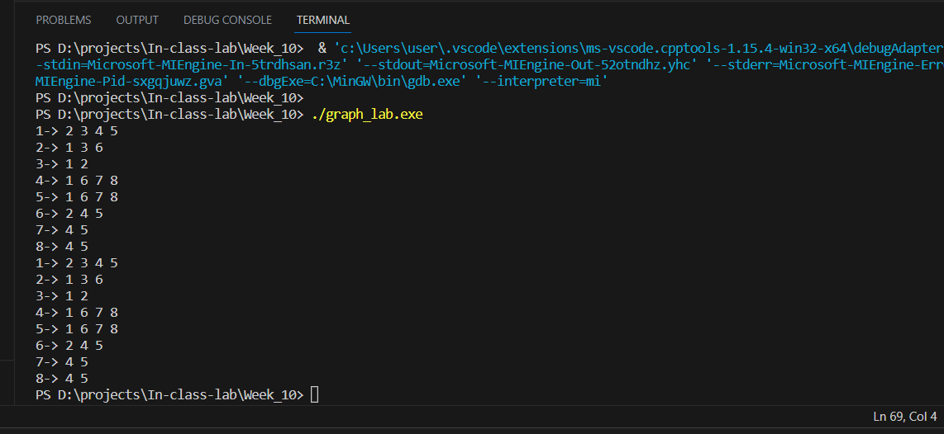

void addedge(int u, int v){

auto result1 = find(nodes[u].neighbours.begin(), nodes[u].neighbours.end(), nodes[v].label);

auto result2 = find(nodes[v].neighbours.begin(), nodes[v].neighbours.end(), nodes[u].label);

if( result1 != nodes[u].neighbours.end()){

        nodes[u].neighbours.push_back(nodes[v].label);

}

If(result2 != nodes[v].neighbours.end()) {

        nodes[v].neighbours.push_back(nodes[u].label);

}

        //select node u and push v into u's neighbour

        //select node v and push u into v's neighbour

    }

Section 2

Sim(4,2) = 2/ 5

Sim(